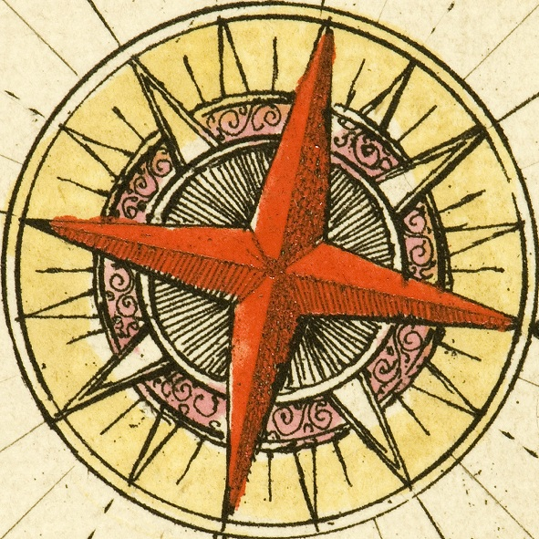
History Seminar Series
Semester 2, 2016–17
Tuesdays 4.00-6.00pm
Room 65/2115 (unless otherwise stated)

14 February 2017: Dr Felix Brahm (German Historical Institute, London), ‘Arms Trade in East Africa: A History of Globalisation, Regulation, and Colonial Rule, 1850s to 1914’

28 February 2017: Dr Alexis Harasemovitch Truax (University of Exeter), ‘Courting the Maghreb: British Power in the Eighteenth Century Mediterranean’’

14 March 2017: Dr Rémy Ambühl (University of Southampton), ‘Joan of Arc, the first prisoner of war?’

Wednesday 26 April 2017: Professor Jacob Lassner (Professor emeritus, Departments of History and Religious Studies, Northwestern University), ‘The Origins of Islamic Martyrdom’ Please note change of date, venue and time for this paper: 5pm in Lecture Theatre B (65/1201)

